August 2020
Mrs. Irvin (Quackenbush)
Advanced Floral Design - Tentative Lesson Plans  This is the tentative schedule of lessons for August 2020---you will be working alongside Floral 1, with more advanced assignments and techniques. Please read the bolded sections below that are listed for Advanced Floral Design and follow your class in Canvas for updates. Feel free to reach out to me via email quackenbushd@lisdtx.org if you have any questions or need help working through an assignment. I am available for tutorials T/TH 3:25-4p.m. | 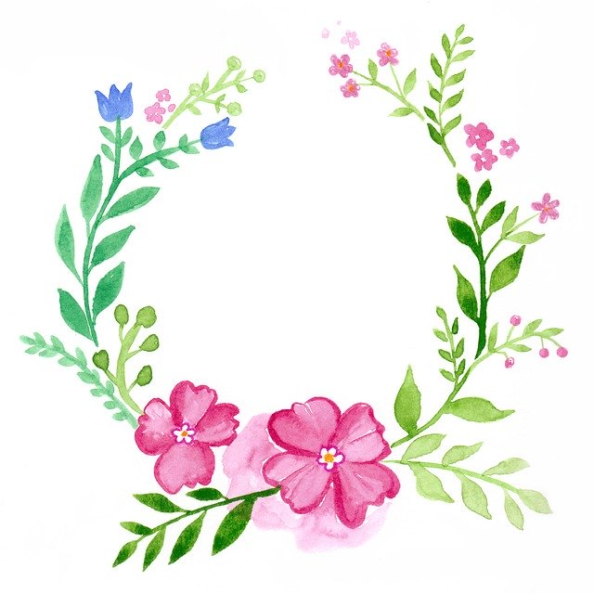
Sunday | Monday | Tuesday | Wednesday | Thursday | Friday | Saturday
 |  |  |  |  |  | 1
2 | 3 | 4 | 5 | 6 | 7 | 8
9 | 10 | 11 | 12 | 13 | 14 | 15
 | 1st Day of School: Welcome Back! “All About Me” flower. | Finish “All About Me” flower and Complete “Ag. Education-Beginning of the Year Survey” | Bell Ringer, then Begin “Basic Floral Design Concepts” Unit 1 notes. Work through slide 9. | Bell Ringer, then continue Unit 1 notes. Work through slide 13. Watch marbling video in Canvas. | Bell Ringer, then continue Unit 1 notes. Work through slide 22.  Watch paper tulip video in Canvas.
*******Advanced Floral Design---- You will be reviewing the history notes and creating a piece of floral material from each era to make a historical arrangement. If you are virtual, please submit your notes via Canvas and watch the appropriate videos. You must complete the daily bell ringer and all assignments that have a turn in box.
16 | 17 | 18 | 19 | 20 | 21 | 22
 | Bell Ringer. Review. Unit 1: Finish PP notes and complete Victorian Era WS. | Unit 1: Create a timeline of periods and submit in Canvas. Instructions located on asgmt. | Unit 1: Identify floral material/arrangements  and match to Era or Eras. | Unit 1: Complete “Basic Floral Design Concepts crossword” to review for quiz. | Quiz: Matching era to description.
*******Advanced Floral Design---- You will finish your notes and create a silk flower design for your specific assigned period with context clues that describe the arrangement. Floral 1 will be reviewing these and identify which period they belong to. If you are virtual, please submit your notes via Canvas. You must complete the daily bell ringer and all assignments that have a turn in box.
23 | 24 | 25 | 26 | 27 | 28 | 29
 | Bell Ringer. Begin Unit 2: Principles and Elements. Follow along with PP and fill in notes to slide 17. | Bell Ringer. Begin Unit 2: Principles and Elements. Follow along with PP and fill in notes to slide 30. | Bell Ringer. Begin Unit 2: Principles and Elements. Follow along with PP and fill in notes to slide 51. | Bell Ringer. Begin Unit 2: Principles and Elements. Follow along with PP and fill in notes to slide 71. | Color and label the mandala to match the one on slide 74. Can use paint and submit virtually or take a photo.
*******Advanced Floral Design---- You will be reviewing the Color notes and painting the color wheel along with creating silk flower color wheel wreaths. If you are virtual and would like to create this project, please reach out to me BEFORE 8/24/2020 and I will package all the supplies needed and you may submit a photo for credit or do the alternative online assignment. You must complete the daily bell ringer and all assignments that have a turn in box.
30 | 31
 | Unit 2: View images of color wheel dyed plant material and answer bell ringer.
Objectives: (A) identify the aesthetic benefits and the history of floral art, particularly as it relates to current practice;
  - (B) classify and identify flowers and plants used in floral design

