August 2020
Mrs. Irvin (Quackenbush)
Floral Design - Tentative Lesson Plans  This is the tentative schedule of lessons for August 2020. Please follow your class in Canvas for updates. Feel free to reach out to me via email quackenbushd@lisdtx.org if you have any questions or need help working through an assignment. I am available for tutorials T/TH 3:25-4p.m. | 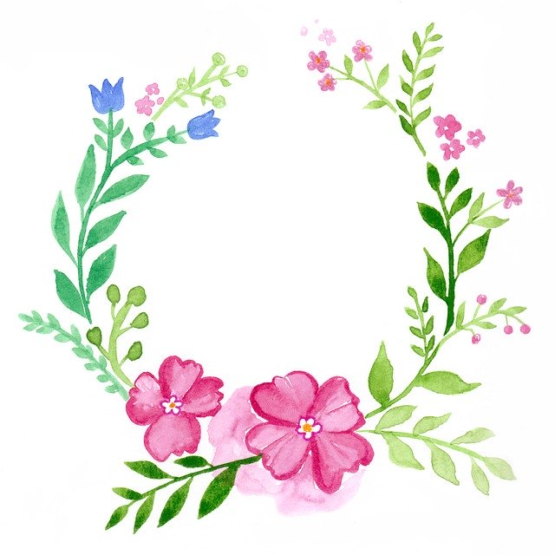
Sunday | Monday | Tuesday | Wednesday | Thursday | Friday | Saturday
 |  |  |  |  |  | 1
2 | 3 | 4 | 5 | 6 | 7 | 8
9 | 10 | 11 | 12 | 13 | 14 | 15
 | 1st Day of School: Welcome Back! “All About Me” flower. | Finish “All About Me” flower and Complete “Ag. Education-Beginning of the Year Survey” | Bell Ringer, then Begin “Basic Floral Design Concepts” Unit 1 notes. Work through slide 9. | Bell Ringer, then continue Unit 1 notes. Work through slide 13. Watch marbling video in Canvas. | Bell Ringer, then continue Unit 1 notes. Work through slide 22.  Watch paper tulip video in Canvas.
16 | 17 | 18 | 19 | 20 | 21 | 22
 | Bell Ringer. Review. Unit 1: Finish PP notes and complete Victorian Era WS. | Unit 1: Create a timeline of periods and submit in Canvas. Instructions located on asgmt. | Unit 1: Identify floral material/arrangements  and match to Era or Eras. | Unit 1: Complete “Basic Floral Design Concepts crossword” to review for quiz. | Quiz: Matching era to description.
23 | 24 | 25 | 26 | 27 | 28 | 29
 | Bell Ringer. Begin Unit 2: Principles and Elements. Follow along with PP and fill in notes to slide 17. | Bell Ringer. Begin Unit 2: Principles and Elements. Follow along with PP and fill in notes to slide 30. | Bell Ringer. Begin Unit 2: Principles and Elements. Follow along with PP and fill in notes to slide 51. | Bell Ringer. Begin Unit 2: Principles and Elements. Follow along with PP and fill in notes to slide 71. | Color and label the mandala to match the one on slide 74. Can use paint and submit virtually or take a photo.
30 | 31
 | Unit 2: View images of color wheel dyed plant material and answer bell ringer.
Objectives: (A) identify the aesthetic benefits and the history of floral art, particularly as it relates to current practice;
  - (B) classify and identify flowers and plants used in floral design

